# Steps to resolve when Datanode services is not starting:
1) go to core-site.xml and check the path of tmp directory. We need to remove and create same directory

rm -rf /home/hdoop/tmpdata

mkdir -p /home/hdoop/tmpdata

2) open hdfs-site.xml and remove datanode and namenode directory

vi hdfs-site.xml

rm -rf /home/hdoop/dfsdata/namenode
rm -rf /home/hdoop/dfsdata/datanode/

mkdir -p /home/hdoop/dfsdata/namenode
mkdir -p /home/hdoop/dfsdata/datanode/

3) Format namenode and start all services. You will find datanode there

hadoop namenode -format

start-all.sh
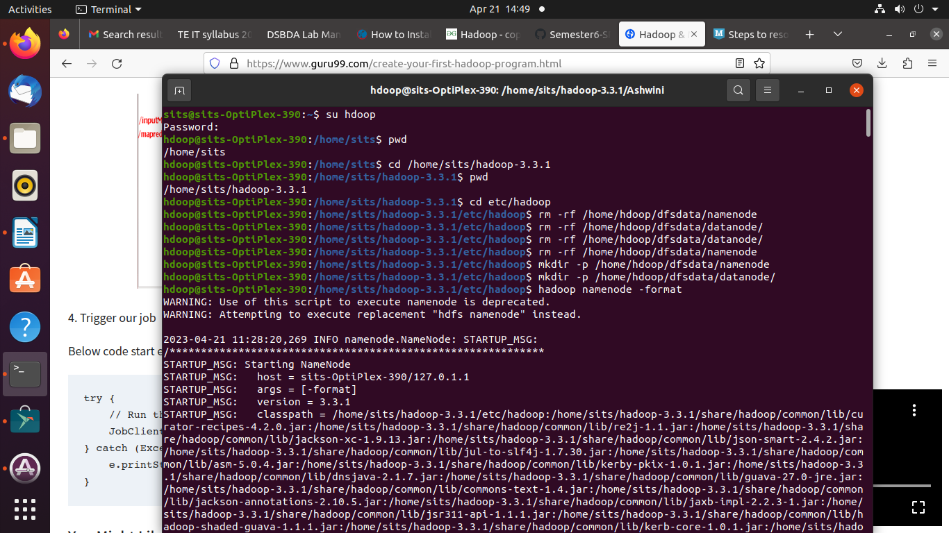

Link for reference: https://learnomate.org/steps-to-resolve-when-datanode-services-is-not-starting/

# Hadoop and mapReduce Example:

1) start-all.sh
2) jps

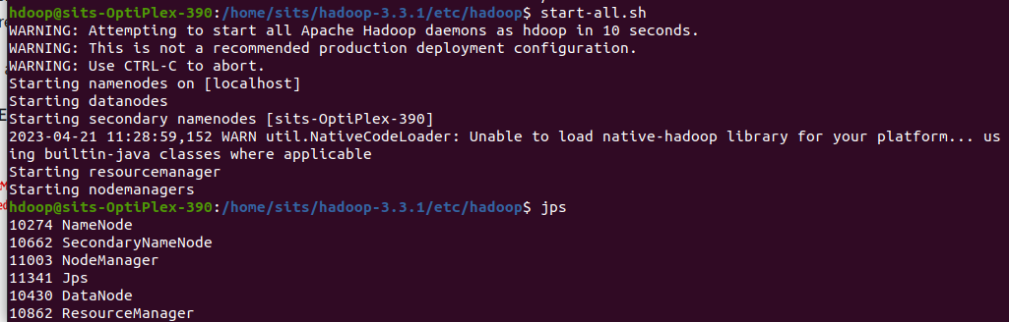
3) Create ‘Ashwini’ folder on /home/sits/hadoop-3.3.1 using create folder(local system)

4) Paste SalesCountryDriver.java SalesCountryReducer.java SalesMapper.java in Ashwini Folder.

5) ls-l
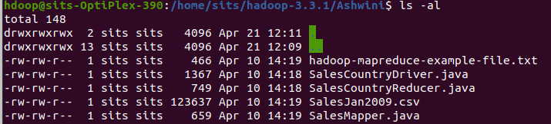

Check the file permissions of all these files , and if ‘read’ permissions are missing then grant the same.

6) Export classpath as shown in the below Hadoop example

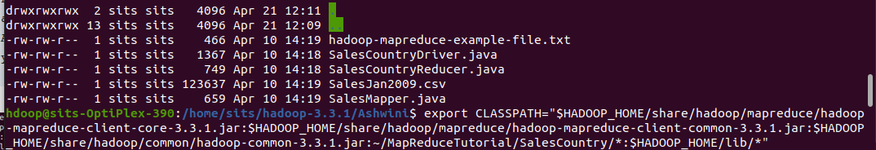

7)Compile Java files (these files are present in directory Ashwini. Its class files will be put in the package directory
j
avac -d . SalesMapper.java SalesCountryReducer.java SalesCountryDriver.java

Error: UnsupportedClassVersionError: SalesCountry/SalesCountryDriver has been compiled by a more recent version of the Java Runtime (class file version 55.0), this version of the Java Runtime only recognizes class file versions up to 52.0

javac --release 8 -d . SalesMapper.java SalesCountryReducer.java SalesCountryDriver.java

This compilation will create a directory in a current directory named with package name specified in the java source file (i.e. SalesCountry in our case) and put all compiled class files in it.

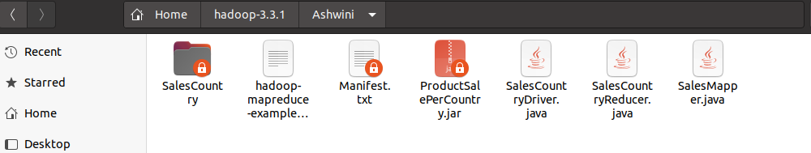
8) vi Manifest.txt

Create a new file Manifest.txt using vi command and add following lines to it.

Main-Class: SalesCountry.SalesCountryDriver

SalesCountry.SalesCountryDriver is the name of main class. Please note that you have to hit enter key at end of this line.

9)jCreate a Jar file

jar cfm ProductSalePerCountry.jar Manifest.txt SalesCountry/*.class

10)Check that the jar file is created
11)Copy the File SalesJan2009.csv from local to hdfs

hdfs dfs -copyFromLocal /home/sits/Desktop/AshwiniInput/SalesJan2009.csv /AshwiniIP

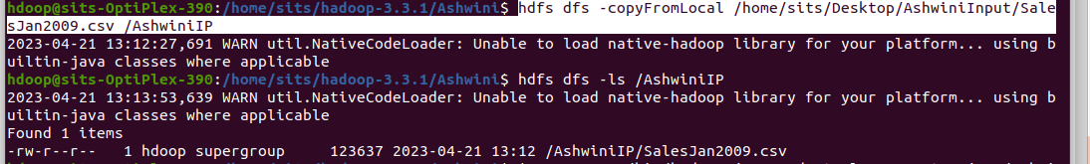
Verify whether a file is actually copied or not.

12) Run MapReduce job

$HADOOP_HOME/bin/hadoop jar ProductSalePerCountry.jar /AshwiniIP /mapreduce_output_sales
This will create an output directory named mapreduce_output_sales on HDFS. Contents of this directory will be a file containing product sales per country.

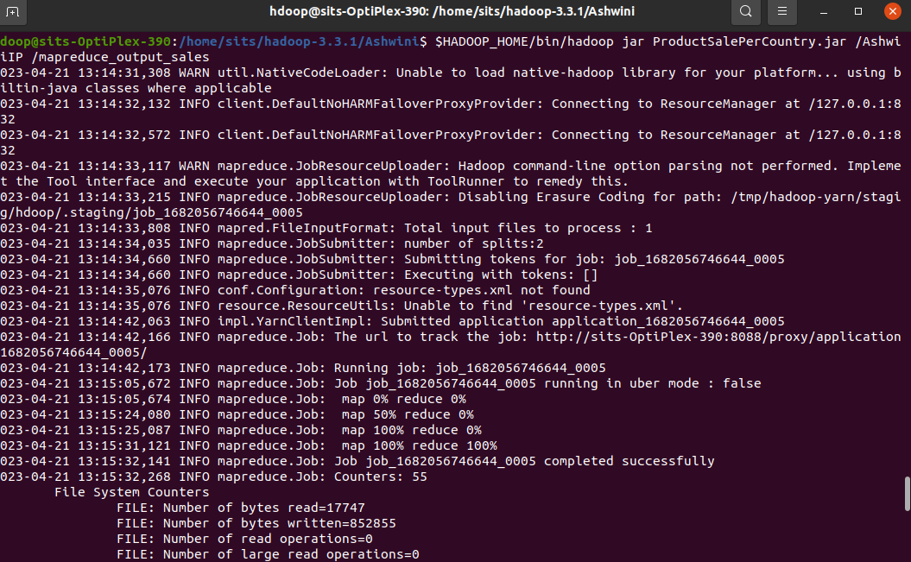
//////

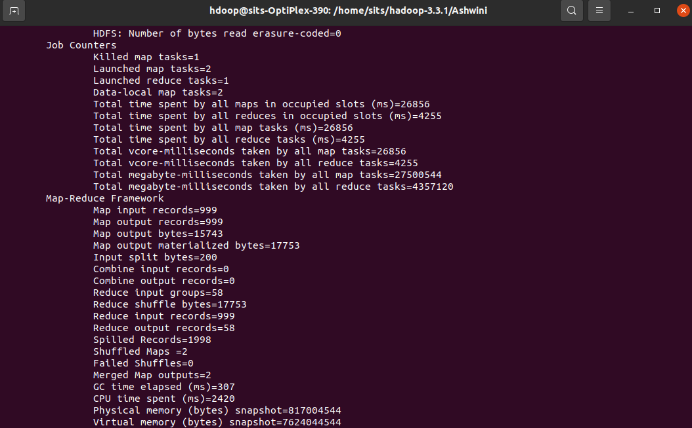
////

The result can be seen through command interface as,

$HADOOP_HOME/bin/hdfs dfs -cat /mapreduce_output_sales/part-00000
